**Lab 6 Prelab**

byJacobLawson

Documentation: C2C Thompson helped me create my flowchart and hardware requirements.

**Which pins will output which signals you need?**

Pins 1.0, 1.1, 1.2, and 1.3 will be used to produce the output signals needed

**Which side of the motor will you attach these signals to?**

Pins 1.0 and 1.1 will be used by the left motor, 1.1 will serve as the ground. Pins 1.2 and 1.3 will be used by the right motor, 1.3 will also be a ground.

**How will you use these signals to achieve forward / back / left / right movement?**

Forward will occur when Pins 1.0 and 1.2 are high / Back will occur when Pins 1.1 and 1.3 are high. Left will be when Pins 1.1 and 1.2 are high. Right will be when Pins 1.0 and 1.3 will be are high

**How you will setup the PWM subsytem to achieve this control.**

Four independent signals will be used to control the two motors, two for each motor. The Reset mode will be used to implement a ground, and a SET/RESET will be used to achieve forward motion at a given speed.

**What are the registers you'll need to use?**

Capture/Compare Control Register

**Consider what additional hardware you'll need (regulator, motor driver chip, decoupling capacitor, etc.) and how you'll configure / connect it.**

A voltage regulator will be needed to prevent the MSP430 from burning itself from producing too much current caused by stalling. A Motor Driver Chip will be used so the voltage produced by the MSP430 will be up to a point that it may be used to drive the motors. Three decoupling capacitors will be needed to be used: two small ones and one large one. The large capacitor will be used to supplement current when the motor draw spikes. One of the small capacitors will be used to smooth noise to the RST pin, while the other will be used to smooth high frequency noise.

**Consider the interface you'll want to create to your motors. Do you want to move each motor invidiually (moveLeftMotorForward())? Or do you want to move them together (moveRobotForward())?**

There will be four subroutines: moveForward(), rotateLeft(), rotateRight(), and moveBackward(). As suggested by the names of the subroutines, the robot will implement “tank movement.” moveForward() will occur when both of the motors move forward. rotateLeft() will occur when the left motor moves backwards and the right motor moves forward. rotateRight() will occur when the left motor moves forward and the right motor moves backward . Lastly, moveBackward() will occur when both motors move backward

**Hardware Schematic**

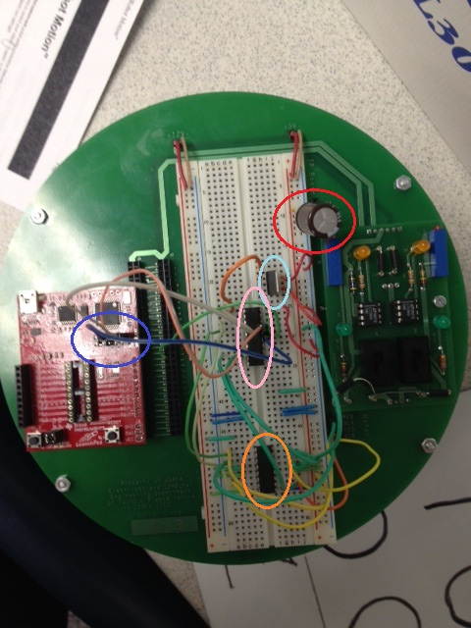

This picture basically outlines what I would do with my devices, however the wiring would be slightly different. I would also throw in two more capacitors to meet my hardware requirements

**Software Flowchart**

